A TRUE FAMILY SAGA
Including the life and death of Clement Bothamley

The story begins with Jane Shepherd Watkin, born in Westminster,London on 19th August 1807. London, at that time was overcrowded and polluted. Cholera and TB were endemic and life expectancy a mere 20 years. Shortly after Jane was born, her family moved Huntingdon, in the Fenland area of East Anglia. The area was rapidly growing due to the increasing demands of its major industry, wool manufacture. Traders of all kinds were attracted to the area, including Jane’s Father, Richard Sheppard Watkin, a saddler.
By 1830, Richard Watkin was a Master Sadler – Journeyman, running his own business in Bourne, Lincolnshire, about 20 miles north of Peterborough. His son and five daughters (including Jane) resided in Peterborough. In 1831, Jane Watkin took the position of House Servant/Barmaid at The Angel Hotel and Posting Inn, in Narrow Street, Peterborough. The landlord there was William Daniels, a 50 year old widower who also owned mail coaches, two farms in the area and ran an Appraisal and Auction business.
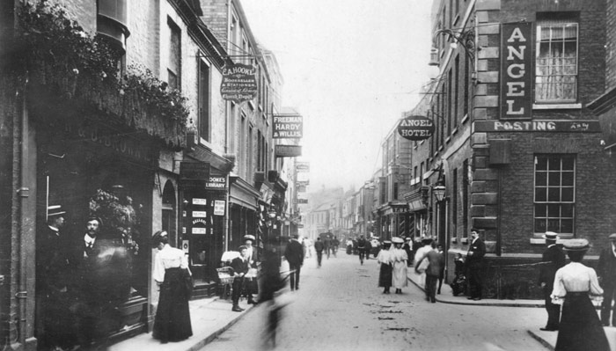
The Angel Hotel
After a short while, William Daniels ‘formed an attachment’ to Jane, and ‘began to pay his address to her’. He visited her constantly and never left her without ‘kissing and blessing’ her. On several occasions during the next few years he promised to marry her, but always found an excuse to delay it. His family were against the relationship and told William that Jane had been seen in an ‘improper and intimate position’ with William’s son. Jane denied the accusation and William said that he believed her. In 1835, at The Angel Hotel, Jane gave birth to a baby daughter. Two weeks later, when she had recovered she went to London, at William’s request, with her baby, staying at the apartment of her sister, Eliza Watkin, (a successful dressmaker), in Hanover Square. William told her that he would follow her there within a month, and that they would marry in London.
William Daniels failed to join Jane in London. Over the next year, he sent her several letters, all in terms of affection, always with excuses for his non appearance. His last letter, dated October 1837 was very different, stating that ‘he had heard that she had been guilty of the most improper conduct and that he should desert her forever, but the child he would take care of. He wished the child to be sent to Peterborough by one of his coaches and it should be kept in one of the union workhouses’.
Jane must have been distraught at receiving the last letter. Unmarried mothers were disgraced, with no chance of finding any employment to support themselves and their child. With the help and support of her sisters and Father, Jane Watkin took William Daniels to The Court of Common Pleas for ‘Breach of Promise of Marriage.’
The trial was held on 16th February 1838 at The Civil Court in London, and reported in both local and national papers. Witnesses were called for both sides and the whole sorry tale was told. The letters that William Daniels wrote to Jane were read out for the jury and a Marriage licence, dated October 1935 was shown. The jury retired and in less than an hour returned a verdict for the Plaintiff, Jane Watkins was awarded damages of £400.
William Daniels died 1840 in Peterborough.
Sometime after the trial, Jane Shepherd Watkin took the post of Ladies Maid to Lady Rosamond Spencer-Churchill, wife of Lord Alan Spencer-churchill and lived between there homes in Oxfordshire and London. Jane’s daughter –named Jane Daniels Watkin, went to live with, and be brought up by her Aunt, Ann Phoebe – nee Watkin and her husband, William Burchnall in Islington, London.
William Burchnall was born in 1814, in Spalding, Lincolnshire – about 15 miles north of Peterborough, where his father ran a Sheep Farm. When he and Ann Phoebe Watkin married on 13th November 1834, at St Margarets, Westminster, London, William began trading as a meat salesman at Newgate Market.
William’s business as meat trader flourished, making him considerable money, and he purchased Boulthurst Farm, with 340 acres in Limpsfield,
William also purchased Doghurst Farm and Gibbs Farm, both near Limpsfield, plus a Tanning and Harness making business in Osbournby, Lincs, with land in Twyford, Lincs.
As both William Burchnall and the Watkins had relatives in the Peterborough area, it’s likely that, at times, they travelled there, either to visit or regarding business and it was probably on those occasions that the young Jane Watkin met Clement Bothamley, who was born on 8th July 1838 at Dogsthorpe, Peterborough, (one of twelve children). By 1861 Clement had taken over the running of his Fathers farm of 141 acres in Paston, Peterborough while his Father (also named Clement) was running a farm of 306 acres in Whittlesey, Cambridgeshire. The Bothamley’s were a very large, extended family, with several branches either running or working on sheep farms in Cambridgeshire, Huntingdonshire, Northamptonshire and Lincolnshire.
On 13th January 1863 Clement Bothamley and Jane Watkin were married at Christ Church, Highbury in the parish of Islington. They then went to live at Crouch House Farm in Edenbridge, Kent – just a few miles from William Burchnall’s farm in Limpsfield. The farm had 213 acres, and Clement made his living as a farmer and hop grower, employing eight men on the farm and two house servants.
In 1869, Clement and Jane had a son whom they named William Burchnall Bothamley. Sadly, the baby died that same year. On the 7th August 1871 they had a daughter – Ann Phoebe (named after Jane’s Aunt.) and on 26th October 1872, another daughter – Edith Kate.
By 1871, Jane Shepherd Watkin had moved into Boulthurst Farm in Limpsfield, acting as Housekeeper to her brother-in-law, William Burchnall. Her sister, Ann Pheobe Burchnall by then was a patient in Northumberland House, Private Lunatic Asylum ( For ladies and gentlemen of middle and upper class) in Stoke Newington, London, where she died in 1873.
On 4th January 1874, Jane Shepherd Watkin. died at Boulthurst Farm, Limpsfield, aged 66 years. Her will, with effects under £600, was proved at the Principal Registry by her daughter, Jane Bothamley, the sole Executrix.
Both sisters where buried in the same grave at St Peters, Limpsfield
Clement Bothamley was one of the executors to his fathers will (with effects under £800) when he died 1st June 1876 at his home at Holme Fen Farm, Near Peterborough.
By all appearances, Clement and Jane seemed to be living a very comfortable life with their daughters on their farm in rural Kent!
By about 1874, in Edenbridge, at Holly Cottage (a large and grand house) on Crouch House Road, lived a young couple, Russell Mellick and his wife, Harriett – nee Bateman. Russell was recorded as a ‘Gentleman’ living by his own means. His family lived in Farnham, Surrey where they had made their fortune as Land Proprietors. Harriett was the daughter of a shopkeeper in Lambeth, which was where she was working as a barmaid for a licensed victualler before marrying Russell on 5th March1872 at South Kennington, Surrey. In October 1872, in Surrey, Harriett gave birth to their son, also named Russell. Their next son, George, born in 1873, in Surrey, only lived a short while.
On 31st May 1875, Russell Mellick died at his home in Edenbridge, aged 32 years.The cause of death was registered as ‘Brights Disease’ ( Kidney disease). His will (with a codicil) with effects under £3,000 was proved at the Principle Registry by his widow, Harriett, the relict and sole Executrix.
On 13th November 1875 in Edenbridge, Harriett gave birth to a daughter, named Catherine Mary Mellick.
Presumably it was some time after this that Clement Bothamley began a secret and illicit affair with the wealthy 24 year old widow, Harriett Mellick
On 7th June 1878, at 2, Cambridge Villas, Westgate-on-sea, Kent, Harriett gave birth to a daughter. The baby’s name was registered as ‘Grace Lily Bothamley Mellick’, and the Father’s name as ‘Clement Bothamley Mellick’. She was baptised on 27th July 1878, at Holy Trinity, Broadstairs, Kent and died on 1st August 1878 at 4, Clarendon Terrace, Broadstairs. On 2nd August 1878, Grace Lily was buried at St Peter the Apostle, in Thanet, Kent.
Clement Bothamley was apparently living a double life, for in the local newspaper dated 6th December 1878, a report on ‘The Edenbridge Fat Stock and Corn Show’, lists him, along with William Burchnall as members of the committee. He was also on the electoral register as resident at Crouch Hall Farm from 1864 until 1880.
Sometime in 1879, Harriett Mellick left her two children with her widowed Mother in Lambeth, and with Clement, travelled to Liverpool where they boarded a ship together, bound for New York – Many people were emigrating to America at that time, being drawn by the opportunities advertised in the press.
Once in America, they headed west, to Kansas, and by 1880, Clement and Harriett resided in Newton, Kansas. With the arrival of the railway in 1871, Newton had become a rough, lawless frontier town of cowboys, gamblers and adventurers, with many documented killings. It had no less than 27 saloons and 8 gambling halls. Clement purchased a house there said to be ‘worth over 5,000 dollars – a great sum of money in those days. They impressed the local folk with their show of wealth. Harriett (who was introduced as Clements wife) rarely ventured out, Clement claiming she was often ‘sickly’, but when she did she always wore expensive clothes and many gems’.
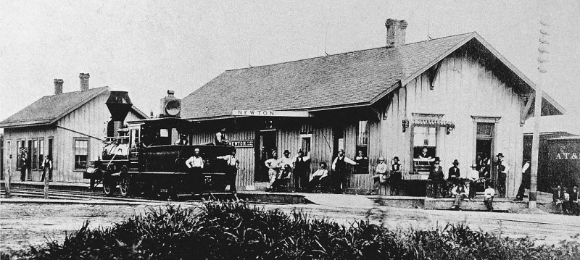
Newton – Kansas 1871
Newton was situated at the end of The Famous Chisholm Trail, Cattle would be driven up from Texas to the Kansas railheads, where they were sold and shipped eastward. Clement began trading as a ‘sheep raiser’ – buying them at a good price and fattening them up, before selling them for a tidy profit. He was said to be a good business man and a shrewd trader.
Meanwhile, back in England, on the 3rd May 1880, Clement Bothamley was declared bankrupt. An announcement in the local paper gave notice that ‘The court has appointed the public examination of the bankrupt to take place at The Town Hall, Tunbridge Wells, on 17th June 1880’.
On 4th June 1880, in Newton, Kansas, Harriett ‘Bothamley’ died, aged 28, two days after giving birth to a daughter. She was buried in Greenwood Cemetery, Newton. Her headstone reads ‘Harriett Bothamley Beloved wife of Clement’.
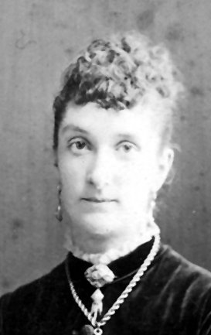
Harriett Mellick
On 18th June 1880, when Clement failed to appear at his bankruptcy examination at Tunbridge Wells, (the principal creditors being Noakes and Son, Hop Factors), the Registrar adjourned the examination ‘sine die’- (without assigning a day for a further hearing) – many people who emigrated at that time took with them all their assets, leaving debts, and were then declared bankrupt in the U.K.
On 19th June 1880, in Newton, Clement’s baby daughter died, aged 17days, and is believed to be buried with Harriett.
In England, Jane Bothamley, with her two daughters moved back in with William Burchnall, who by now was very wealthy – he had investments in many businesses and was a member of the new Metropolitan Meat Market, Smithfield, with a large staff of employees. His London residence was now a palatial villa at 25, Little Britain, Aldersgate, where he employed domestic servants and then a live-in teacher for the two girls, who resided between Limpsfield and London.
After Harriett’s death, Clement Bothamley sold his house in Newton and purchased a large ranch of 640 acres in Sedgewick, Kansas. He had a house built, with premises to board the hired hands. Over the next couple of years he began to stock the ranch with horses, cattle and sheep. He would have gone into Newton regularly on business and financial matters.
At some point he met the ‘beautiful and notorious’ Nellie Bailey. She would have been about 20 years old and had been previously engaged to a man named Alvin Lakeside, before breaking it off to marry Shannon Bailey, a wealthy money broker of Newton who was much older than Nellie. It was said that Shannon Bailey was ‘a serious man who preferred a quiet life, while Nellie loved the social life and spending her husband’s money’
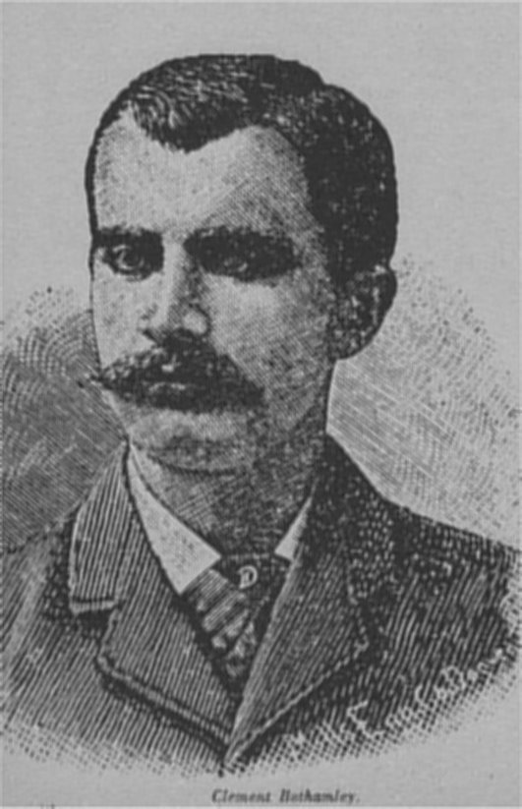
Clement Bothamley
Nellie and Clement (by then in his early 40s) ‘formed an attachment’ and on 9th June 1883, Nellie secretly Joined Clement at his ranch in Sedgewick. Clement had told his hired hands beforehand that he was expecting his sister, Bertha, from England, and it was this ‘Bertha’ that Nellie pretended to be. According to later testimonies she rarely left the house, but when she did she always wore a white veil over her face (said to protect her from the sun) and spoke in a whisper. – Several of the hands were from Newton and may have recognised her!
As soon as she had arrived at Sedgewick, she and Clement started to make plans to drive 2,500 sheep down the Chisholm Trail to Texas – about 800 miles, sell the sheep and start a new life there together. It would be a long and arduous journey over rough ground, crossing creeks and rivers and, with the sheep would take over 2 months. Clement built a ‘house’ on wheels, drawn by oxen for Nellie’s comfort and on 22nd August 1883, they set off with a spring wagon drawn by horses, several milch cows, saddle horses and a number of hired hands along with wranglers to take charge of the horses. For the journey, Nellie wore ‘a cloth mask with holes for her eyes and around her waist she wore a thick rope, attached to which was a six shooter.
Due to adverse weather conditions, they only managed a few miles a day, and on 7th October 1883, they had just crossed over into Oklahoma – Indian Territory, where they made camp at Hackberry Creek. That night all of the hands were about half a mile away from the camp guarding the sheep when they heard a loud gunshot. Several of them hastened to the camp to see what had happened and found Nellie calmly standing outside the carriage. She told them that something terrible had happened and when they looked inside the carriage, found Clement dead, with a bullet hole through his head, just below his right eye, and a gun on the floor. Nellie claimed that Clement had shot himself, and it was decided to take the body back up the trail a few miles to Skeleton Ranch (a place where herds could be contained and basic amenities offered to the drovers). It was there they buried him in a make shift coffin, in a shallow grave, and the next morning set off with the sheep for Texas as originally planned.
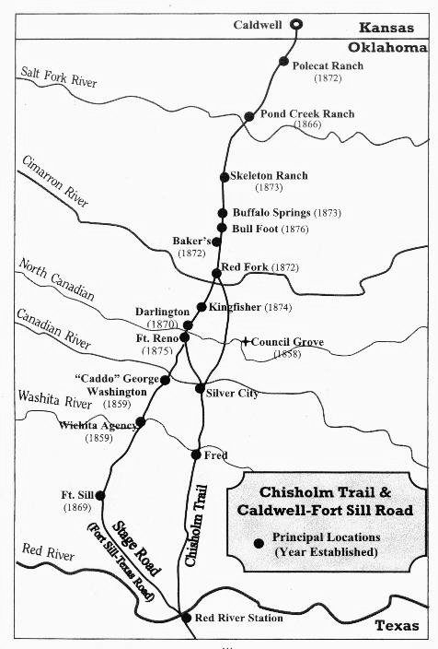
The Chisholm Trail
Mr A.W. Carr of The British Association of Kansas (of which Clement Bothamley was a member) received word from Skeleton Ranch of Clements death. He ordered that all of his belongings, along with the sheep, worth 10,000 dollars be brought back to Newton, and that his body should be exhumed, placed in a sealed zinc box and also brought back.
Deputy U.S. Marshall, Cash Hollister, who was sheriff of Caldwell – a few miles north of Skeleton Ranch, and who had jurisdiction in Indian Territory, was also informed. He, along with a posse of two, rode south and caught up with Nellie. After taking statements and looking at the crime scene, he arrested ‘Bertha Bothamley’ for the murder of Clement Bothamley. During initial investigations he learnt of a letter Nellie/Bertha had sent to Mr Johnson, Registrar of deeds in Newton and telegraphed in time to stop the recording of the deed.
Once in custody, Nellie had no choice but to reveal her true identity. She was held for fifteen months whilst evidence and witnesses were gathered, though she was given freedom at times to go into town or to visit her family. During that time details of Clement’s tangled and deceitful affairs, in both America and England emerged. The sensational news was reported in all the newspapers, and by the time of the trial, public opinion had swung against him.
It’s interesting to note that the investigating sheriff, Cash Hollister and his posse had all been killed in separate incidences, whilst attempting to make arrests, and so could not testify!.
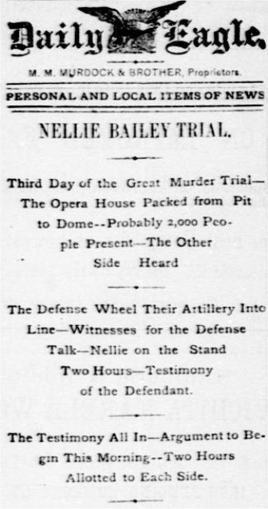
Newspaper Headline of the trial in Wichita.
The trial which lasted five days began on 18th January 1885 and was held at The Wichita Opera House, Kansas. It was reported fully in The Wichita Daily Eagle and was said to be packed from pit to dome with about 2,000 people present.
The following is a brief account of the trial:-
The prosecution began their case -:
Witness, Mrs Haynes, kept a ranch in Indian Territory and recalled that Nellie went to their supply store and enquired where she could find Indians as she had a lot of jewellery to trade with them. Witness said her dress struck her as odd - she wore a man’s large hat which shaded her face and had a pistol in her belt. She then later saw Bothamley passing by on horseback, Nellie joined him. ‘They both galloped around, firing several shots and seemed to be handy with a pistol’.
Witness Mrs Wells, lived at Skeleton Ranch, recalled that on the night Clement Bothamley was buried there, she saw Nellie whispering secretly with Dodson, one of the ranch hands, she then saw her writing letters for several hours. One of these letters was addressed to John Johnson, Registrar of deeds in Newton, which she handed to one of the sheepherders who mailed it for her. Several other witnesses who were at Skeleton ranch, said that Nellie showed no signs of grief, and was seen in deep conversation with some of the hired hands.
It was revealed to the court that, the day before they started out on the trip, a deed had been made out transferring Clements lands in Kansas (worth 20,000 dollars) to his sister, Sara A. Laws. Sometime afterwards, a further deed transferred the lands to Bertha Bothamley. (N.B. - My research shows that Clement did have a sister named Sara A., who had married Fred Summers and lived in Huntingdonshire, England. He had another sister, Drusilla who had married William Laws and together, in 1880 they had emigrated to America, settling in Florida. Needless to say, he did not have a sister named Bertha) A Letter was then read out to the court that had been sent to the Registrar of deeds – ‘Enclosed find deed and 2 dollars, don’t know the exact amount to send, return deed and change to my address at Fort Reno, Indian Territory, signed Sara A Laws’ (Fort Reno was on the Chisholm trail several miles south of Skeleton ranch, in Oklahoma).
Two trunks that had been seized and which Nellie had claimed were hers were opened. – One containing silk and satin dresses and jewellery worth 7,000 dollars (probably Harriett’s), the other containing solid silver tableware.
The doctor who had examined Clements body was called. He stated that in his opinion Clement had not committed suicide – he thought a person ‘would rather shoot themselves through the temple perhaps, but not just below the eye’. On cross examination he was forced to admit that he had very little experience dealing with suicide cases.
Another witness, a ranch hand stated that on the night of Clements death, ‘Nellie said that there was something wrong with her ear and asked him to look at it, saying she thought she might have been shot’.
It was then revealed that Nellie had had another relationship, with a Robert Reece, whilst married to Shannon Bailey, supported by letters ‘of the most affectionate kind, that where read out in court, and that a ‘marriage’ had taken place in April 1883. The marriage registration was shown in court as proof. Then a letter written by Nellie to Reece, just before she joined Clement at Sedgewick was shown, telling him that she had some business in Kansas and would return soon with 18,000 dollars.
The case for the defence rested on the fact that Nellie had no motive for murdering Clement Bothamley as she already had the deeds for his ranch, and that the prosecution had done everything in their power to try to blacken her name.
Nellie took the stand and was there for two hours. She contained herself admirably and never wavered. She told the court that she and Shannon Bailey had separated on mutual agreement and that he had given her 4,000 dollars. Of her sham marriage, she claimed it was ‘all taffey’ – that she was ‘just having fun and never took it seriously’ and that the letters just reflected her flirtatious personality, adding that she did not realise the marriage was ‘proper’.
She said that when she met up again with Clement, she realised ‘this was the man she loved, he was handsome, intelligent, fun and adventurous’. She claimed that she had gone into business with Clement, giving him 3,500 dollars towards the sheep, and that he had handed the property over to her because he wanted her to have it.
He had also told Nellie that Harriett was never his wife, that he had a lawful wife and two children in England, adding that they were being cared for by his wife’s relatives far better than if he had stayed. She said that Clement had the deeds changed to stop his wife in England claiming his property.
Nellie then went on to describe how Clements health had started to deteriorate. She said that he suffered with rheumatism and sciatica (a previous witness had stated that he sometimes saw Clement with a walking stick in Newton). After they had started out on the trail, Clement saw a Dr Dwight at Caldwell who prescribed morphine for his increasing pain and Nellie stated that she had begged him to go by rail to Texas, saying she would hire someone to help drive the sheep, but Clement ‘would have none of it.’ Dr Dwight, when on the stand verified Nellie’s statement. She told how Clement was in so much pain sometimes that he said he could kill himself, and that he became addicted to the morphine. Two ranch hands who had previously taken the stand also said that they had heard Clement saying that he felt like killing himself.
Nellie maintained, as she had done all along, that Clement had shot himself, either accidentally or on purpose.
No further witness’s appeared in court to support much of Nellie’s testimony.
The Prosecution painted a picture, of a cold callous money grabbing young woman.
The Defence painted a picture of a man racked in pain and tortured with guilt over his wife and children in England.
The jury was out less than 15 minutes before returning a verdict of ‘not guilty’, and 22 year old Nellie Bailey was acquitted, to much applause.
Clement Bothamley (1838 – 1883), was buried in an unmarked grave in Greenwood Cemetery, Newton, Kansas.
After the trial, Nellie collaborated with an author, Mary E Jackson to write her book ‘The life of Nellie C Bailey’ – a biased, flattering and certainly in parts fictitious account of her life and events, written in the style of a romantic novel. The account she gave about Clement’s life and events in England was wholly incorrect! She then embarked on a tour of the west to promote her book which, according to Nellie, sold over 10,000 copies in the first year alone.
It seems that Nellie may have then married a further two or three times, always keeping her surname as Bailey. Her last marriage on 23rd November 1898 was to Leo Brigel. They then ran a restaurant in Ohio which is where Nellie Bailey died on 25th February 1926, aged 63years.
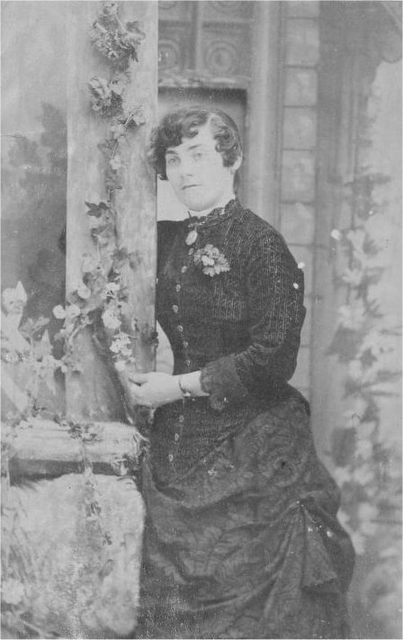
Nellie Bailey – From her book cover!

Epilogue
England:-
On 21st May 1892, William Burchnall died suddenly at his home in London, aged 78 years, and was buried in the same grave as his wife and sister-in-law at St Peters, Limpsfield.
The report of his funeral, in the local newspaper stated that he was ‘a highly esteemed gentleman, well known and in every way respected as one of the largest salesman in the Smithfield Meat Market. His large staff of employees journeyed from London to pay their last tribute of respect. The remains of the deceased, which were placed in a massive polished oak coffin with brass furniture, were conveyed from London to Limpsfield Church in a hearse drawn by four horses followed by three mourning coaches, each drawn by four horses. The first coach carried Mrs Bothamley, Miss A Bothamley, Miss E Bothamley and Miss Parker.’ At Limpsfield, blinds were drawn and all the shops closed’.
His long term housekeeper and friend, Louisa Parker (born 1835) along with two of his Business partners were executors of his will which at probate stated effects of £64,073. 15s 9d
Eagleton and Sons, 40, Chancery Lane, London acted as Solicitors for the Executors regarding the auctioning of the stock and equipment at Boulthurst, Doghurst and Gibbs Farms.
In 1896, Jane and Clements daughter, Ann Phoebe Bothamley married Leonard Osborne Eagleton, of Eagleton and Son Solicitors and resided at Hurst Lodge, Bexley, Kent, with domestic servants, a nurse and a cook. In the 1911 census, they were residing at 7 Stanley Crescent, Notting Hill Gate, London, with servants, a children’s maid and a cook.
Jane Bothamley ( Clements widow), along with her other daughter, Edith Kate, boarded at Louisa Parker’s house in Forest Hill, Lewisham, before all three shared a house together at 6, Sylvan Road, Upper Norwood, Surrey (Edith was recorded as the ‘head’ on the 1911 census), all of them ‘living on own means’ and employing domestic servants. Louisa Parker died sometime after 1911 and Jane and Edith moved to 12, Mowbray Road, Upper Norwood.
On 29th January 1925, Jane Bothamley died. The death notice in the paper read ‘At Westfield, Upper Norwood, in her 90th year, Jane, widow of Clement Bothamley, of Edenbridge, Kent.’ Probate recorded effects of £211. 1s 11d to Edith Kate Bothamley,spinster.
Edith then travelled, at least twice, to India in 1926 and to Canada in 1927 before returning to her home in Mowbray Road. She never married, and died in December 1970 aged 98 years.
Phoebe and Leonard Eagleton had three daughters – Norah Buchanan Eagleton, born 1900, died 1985, Surrey - spinster, Aileen Cecil Eagleton, born 1902, died 1984, East Moseley, Surrey - spinster - (who became a renowned artist and painter), and Margaret Ursula Eagleton, born 1905, died 1991, Surrey - (who in 1932 married Corrie Ivimey. Phoebe and Leonard Eagleton purchased a further home – ‘Falconers’, in Liphook, Hants. When Leonard died in 1939, probate recorded effects of £17,717. Phoebe died in September 1971, in Surrey, aged 100 years.

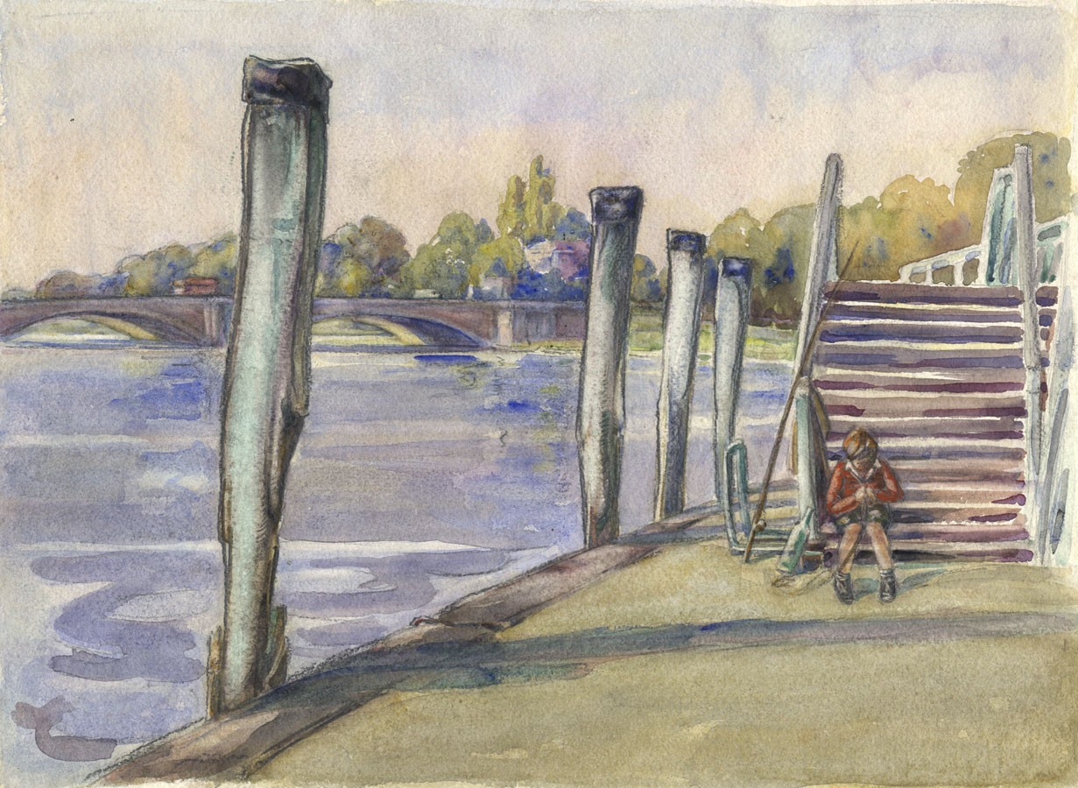
Aileen Eagleton (1902-1984) - Mid 20th Century Watercolour, ‘Playing by the River’
(A view towards Hampton Court Bridge from East Moseley)

References:-
U.K. Birth Marriage and Death index
U.K Parish Records
U.K. Census records
U.K. Wills and Probate records
U.K. Newspapers and Periodicals
U.K. Passenger lists
U.K. Telephone Directories
U.K. Electoral records
U.S. Census records
U.S. Newspapers and Periodicals
www.findagrave.com.
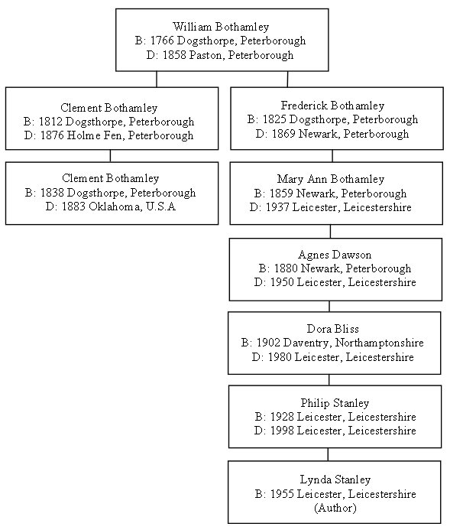
Updated 18th Dec 2020 - All copyright Lynda Pearce

